Lab 8.1.4.8 Designing and Implementing a Subnetted IPv4 Addressing

1. Topology

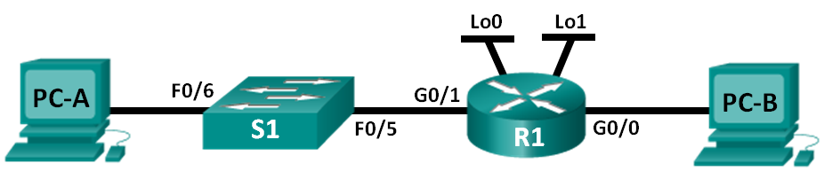

1. Objective

Design a Network Subnetting Scheme

1. Background / Scenario

In this lab, starting from a single network address and network mask, you will subnet the network into multiple subnets. The subnet scheme should be based on the number of host computers required in each subnet, as well as other network considerations, like future network host expansion.

1. Design a Network Subnetting Scheme
   1. Create a subnetting scheme that meets the required number of subnets and required number of host addresses.

In this scenario, you are a network administrator for a small subdivision within a larger company. You must create multiple subnets out of the **192.168.0.0/24** network address space to meet the following requirements:

* The first subnet is the employee network. You need a minimum of 25 host IP addresses.
* The second subnet is the administration network. You need a minimum of 10 IP addresses.
* The third and fourth subnets are reserved as virtual networks on virtual router interfaces, loopback 0 and loopback 1. These virtual router interfaces simulate LANs attached to R1.
* You also need two additional unused subnets for future network expansion.

**Note: Variable length subnet masks will not be used. All of the device subnet masks will be the same length.**

Answer the following questions to help create a subnetting scheme that meets the stated network requirements:

* + - 1. How many host addresses are needed in the largest required subnet? ____25_________________
      2. What is the minimum number of subnets required? __________6_______________________
      3. The network that you are tasked to subnet is **192.168.0.0/24**. What is the /24 subnet mask in binary?

**_________________11111111. 11111111. 11111111. 00000000**

* + - 1. The subnet mask is made up of two portions, the network portion, and the host portion. This is represented in the binary by the ones and the zeros in the subnet mask.

In the network mask, what do the ones represent? ______Sección Red

In the network mask, what do the zeros represent? ______Sección Host

_________________________________

To subnet a network, bits from the host portion of the original network mask are changed into subnet bits. The number of subnet bits defines the number of subnets. Given each of the possible subnet masks depicted in the following binary format, how many subnets and how many hosts are created in each example?

**Hint**: Remember that the subnet bits (depicted in bold type face) are the bits that have been borrowed beyond the original network mask of /24. The /24 is the slash prefix notation and corresponds to a dotted decimal mask of 255.255.255.0.

(/25) 11111111.11111111.11111111.**1**0000000 **255.255.255.128**

Number of subnets? __2 a la 1 = 2__________, Number of hosts? 2 a la 7 – 2= 126___

(/26) 11111111.11111111.11111111.**11**000000 **255.255.255.192**

Number of subnets? __2 a la 2 = 4____________, Number of hosts? __2 a la 6 – 2 =62__________

(/27) 11111111.11111111.11111111.**111**00000 **255.255.255.224**

Number of subnets? __2 a la 3 = 8______________ Number of hosts? __2 a la 5 – 2 = 30_______

(/28) 11111111.11111111.11111111.**1111**0000 **255.255.255.240**

Number of subnets? _2 a la 4 = 16___________ Number of hosts? _2 a la 4 – 2 = 14________

(/29) 11111111.11111111.11111111.**11111**000 **255.255.255.248**

Number of subnets? __2 a la 5 = 32____ Number of hosts? ___2 a la 3 – 2 = 6 ______________

(/30) 11111111.11111111.11111111.**111111**00 **255.255.255.252**

Number of subnets? __2 a la 6 = 64______________ Number of hosts? _2 a la 2 – 2 = 2 _____

* + - 1. Which subnet masks meet the required number of minimum host addresses? **__/25 /26 /27**
      2. Which subnet masks meets the minimum number of subnets required? _**/27** /28 /29 /30

Which subnet mask meets both the required minimum number of hosts and the minimum number of subnets required? _________/27_____________________________________________________

* 1. Record the subnet information.

Fill in the following table with the subnet information:

255.255.255.**1110 0000 256 – 224 = 32**

**192.168.0. 000 00000 subred**

**001**

**010**

**11111 broadcast**

|  |  |  |  |  |
| --- | --- | --- | --- | --- |
| Subnet Number | Subnet Address | First Usable Host Address | Last Usable Host Address | Broadcast Address |
| 0 | 192.168.0.0 | 192.168.0.1 | 192.168.0.30 | 192.168.0.31 |
| 1 | 192.168.0.32 | 192.168.0.33 | 192.168.0.62 | 192.168.0.63 |
| 2 | 192.168.0.64 | 192.168.0.65 | 192.168.0.94 | 192.168.0.95 |
| 3 | 192.168.0.96 | 192.168.0.97 | 192.168.0.126 | 192.168.0.127 |
| 4 | 192.168.0.128 | 192.168.0.129 | 192.168.0.158 | 192.168.0.159 |
| 5 | 192.168.0.160 | 192.168.0.161 | 192.168.0.190 | 192.168.0.191 |
| 6 | 192.168.0.192 | 192.168.0.193 | 192.168.0.222 | 192.168.0.223 |
| 7 | 192.168.0.224 | 192.168.0.225 | 192.168.0.254 | 192.168.0.255 |

**.256**

* 1. Complete the diagram showing where the host IP addresses will be applied.

On the following lines provided, fill in the IP addresses and subnets masks in slash prefix notation. On the router, use the first usable address in each subnet for each of the interfaces, Gigabit Ethernet 0/0, Gigabit Ethernet 0/1, loopback 0, and loopback 1. Fill in an IP address for both PC-A and PC-B. Also enter this information into the Addressing Table on Page 1.

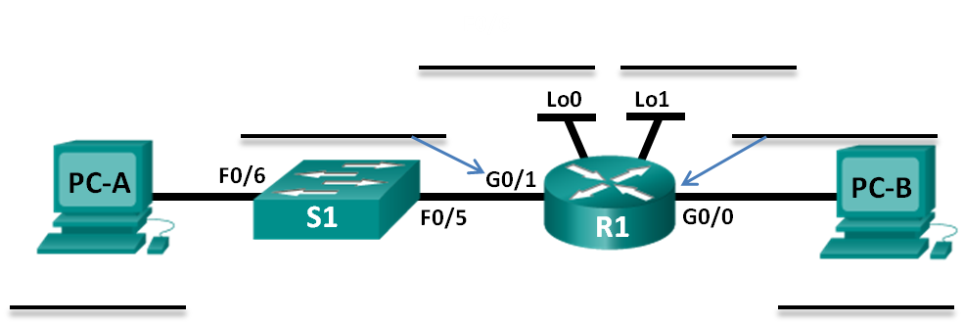

|  |  |  |  |  |
| --- | --- | --- | --- | --- |
| Device | Interface | IP Address | Subnet Mask | Default Gateway |
| **R1** | **G0/0** | **192.168.0.33** | **255.255.255.224** | N/A |
|  | **G0/1** | **192.168.0.1** | **255.255.255.224** | N/A |
|  | **Lo0** | **192.168.0.65** | **255.255.255.224** | N/A |
|  | **Lo1** | **192.168.0.97** | **255.255.255.224** | N/A |
| **S1** | **VLAN 1** | N/A | N/A | N/A |
| **PC-A** | **NIC** | **192.168.0.30** | **255.255.255.224** | **192.168.0.1** |
| **PC-B** | **NIC** | **192.168.0.62** | **255.255.255.224** | **192.168.0.33** |